ELECTROPHYSIOLOGY STUDY, 3D MAPPING AND ABLATION REPORT

Patient Name: Gurunath Gadgil | Consultant: Dr. Gurunath Parale
Age: 67 | Operator: Dr. Chinmay Parale
Sex: Male | Procedure Date: 15/04/2026
Date: 16/04/2026 | Hospital: Ashwini Hospital, Solapur (CARTO)

Clinical Presentation and Indication: Pedal edema, palpitations and incessant slow wide complex tachycardia (likely VT) with an RBBB, left axis morphology. Known case of CAD post PCI to RCA with mild LV dysfunction (LVEF 40-45%) and RWMA of inferior and inferoseptal segments.

Baseline:
Access and Catheters | 6F, 8F RFV, 8F RFA (Thermocool Smarttouch CF Catheter)
ECG | Incessant WCT with 1:1 VA association and a cycle length of around 600 ms. Tachycardia QRS morphology RBBB with leftward axis, isoelectric lead I, negative inferior leads.

Ablation:
Ablation | A negative HV interval during tachycardia and intermittent VA dissociation confirmed the diagnosis of ventricular tachycardia. Using a Thermocool Smarttouch CF bidirectional catheter and CARTO 3D mapping system, entire LV was mapped using retrograde and transseptal approaches. Activation and voltage mapping was done in sinus rhythm as the VT kept terminating with catheter induced PVCs. Voltage mapping showed low voltage areas and areas of scar in the basal and mid inferior and inferoseptal segments. Fractionated EGMs, LAVAs and areas with late potentials were targeted in the scarred regions and border zones with the endpoint of abolition of local signals.

Post-ablation: No VT inducible with ventricular burst pacing (at 250 ms) and extrastimulus testing (with 3 extrastimuli at 2 different sites delivered till refractoriness)

Conclusions:

- Scar related incessant ventricular tachycardia
- Coronary artery disease with mild LV dysfunction
- Successful substrate modification done guided by 3D mapping system (CARTO)

Images attached below:

Pre-ablation ECG:
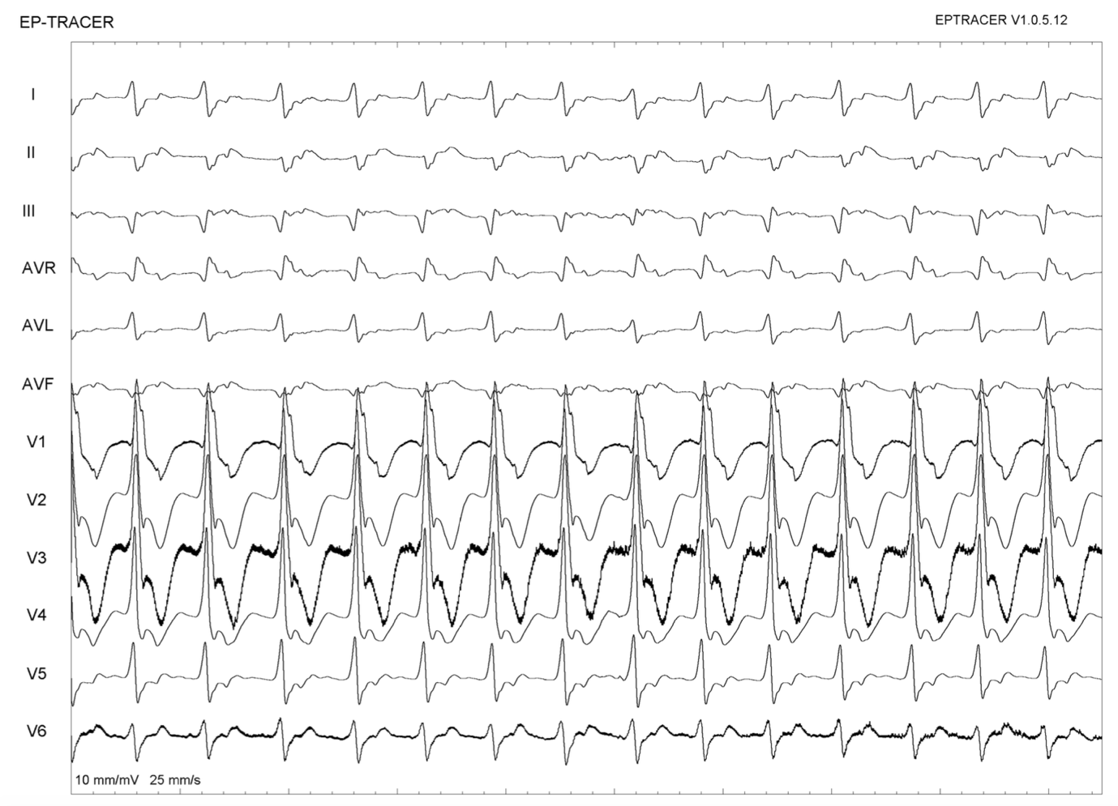

3D Map:

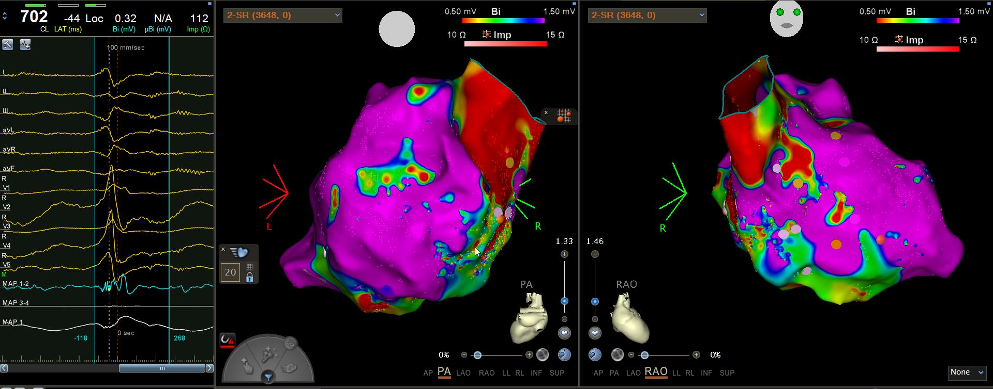

Ablation:

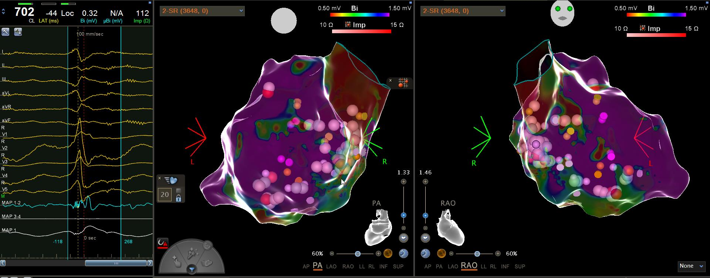

Post Ablation ECG:

